**1.                   Is there a scope of work  or feature list document available for the mapping features offered  by Jibestream? Few high-level that cross my mind and areas we would like to see:**

* 1. **Calculates and visualizes the optimal route from A to B:**

This is an **Out of the Box** feature. Jibestream’s solution is completely ADA (Americans with Disabilities Act) compliant and can provide alternate directions that avoid stairs and escalators and redirect them to an elevator instead. Jibestream’s Text Directions can also be passed through a TTS (Text-To-Speech) library and converted to audio instructions for the visually impaired.

See images below for an example from our deployment at the Mall of the Emirates.

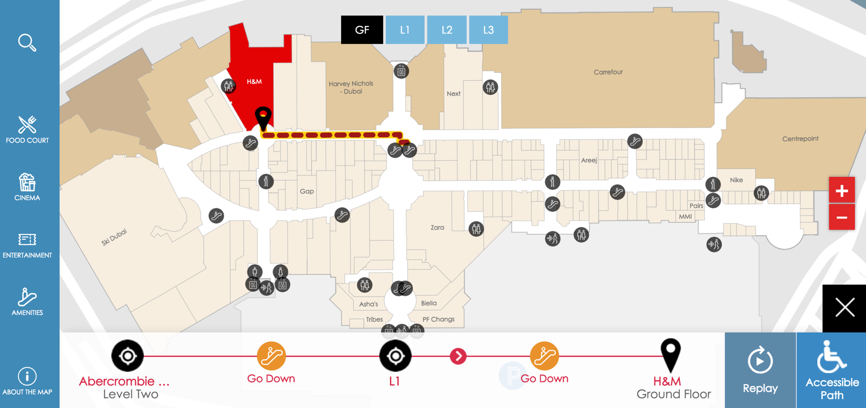

*Image 1 below shows regular wayfinding, where the user is navigating using escalators.*

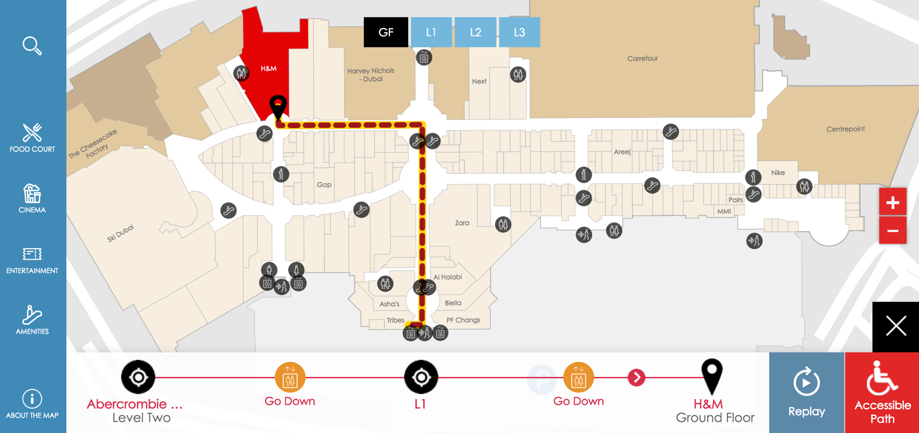

*Image 2 shows accessible (or disabled) wayfinding by avoiding “vertical movers” and navigation is done using the elevators instead.*

* 1. **Labels for marking POIs with text**

This is an out of the box feature. Labels can be managed via our CMS or our APIs. Labels can be in a text format or other objects such as HTML, images etc.

* 1. **Icons as universally understandable graphical information**

Iconography will be completely under WEM’s control. You can use Jibestream’s set of default icons or use custom WEM icons.

* 1. **Info-window (annotations), filled with variable text, images, icons or clickable links**

This is an out of the box feature.

* 1. **Move seamlessly from inside to outside and vice versa**

This is an out of the box feature for the private mall property – parking, outdoor POIs, etc. For public spaces, Jibestream maps can be superimposed on outdoor maps (Google, Mapbox, Apple, etc.) to provide the indoor to outdoor navigation seamlessness.

* 1. **Over several floors**

This is an Out of the Box feature. As demonstrated earlier, ADA wayfinding is possible over several floors too.

* 1. **Text-based routes (turn by turn navigation, classic step by step navigation)**

This is an Out of the Box feature, deployed in 1000+ venues.

* 1. **Flexible customization of colors, icons, zoom levels, etc. by the customer**

Jibestream maps will completely follow the branding guidelines of WEM. Every layer of the map is completely customizable.

* 1. **Customizable styling rules change the appearance of the map during use**
  2. **Rotation, panning**
  3. **Customized contextual reporting and geo-analyses services:**
  4. **Calculation of walking routes and movement patterns based on recorded positions**
  5. **Displayed as point clouds and heat maps**
  6. **Aggregation of data from multiple entities (people, groups, jobs, vehicles, etc.)**
  7. **Dashboard access.**
  8. **Dynamically update Map information.**
  9. **Integration ability with any beacon vendor(ie, hardware agnostic)**
  10. **Turn by Turn refresh rate**
  11. **It will be also nice to have Galaxyland mapped and we would like to provide a turn by turn experience. Not an immediate requirement but something to keep in mind.**

**2.                   Please provide us with the documentation and sandbox account. Also, it might be helpful to provide us a brief on the capabilities of this sandbox.**

**3.                   As for a Proof of concept, we would like to experience the Jibestream mapping experience with turn by turn navigation for what we call Phase 1 of WEM**

**4.**

**a.                         From the MS store onwards( including the area around Icepalace) to Homesense , Hudsons Bay and West 49. No turn by turn in Galaxyland.**

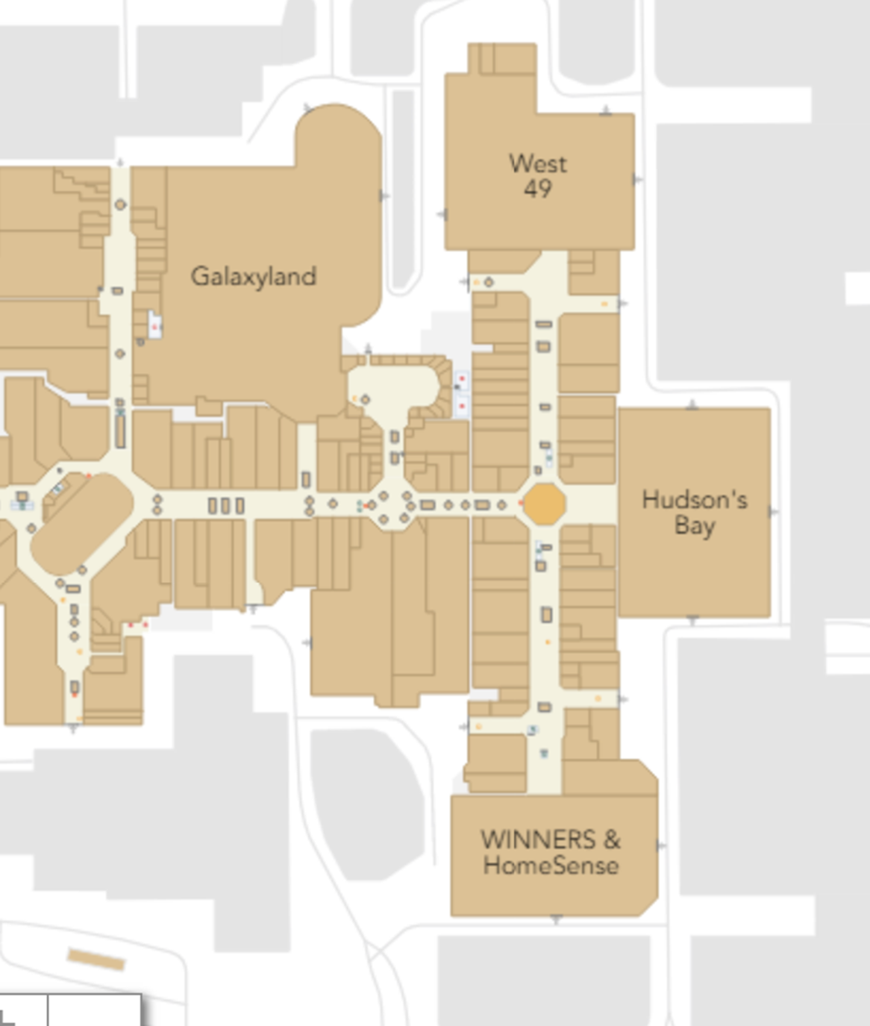

**b.       Let us know what is involved to get this underway.**

**c.       Our focus is exploring and finding a replacement mapping vendor for our MyWEM App.**

**Please let us know if we can be of help or require further clarification.**

**The key stakeholders from WEM are on this thread and will chime in if it’s pressing prior to my return to office on 15th.**

**Vinay Iyer | Enterprise Account Executive**

**JIBESTREAM**

**D: (647) 252-2909**

**C: (204) 880-3892  
E:**[**viyer@jibestream.com**](mailto:viyer@jibestream.com)**| W:**[**jibestream.com**](http://www.jibestream.com/)

**455 Dovercourt Rd. Suite 101 Toronto ON M6H 2W3**

**Webinar: How Desjardins Built a Smart Workplace |**[**Register Today!**](https://hubs.ly/H0f4kRc0)